**Cloud Computing Experiment 4**

**Name**: Vishwa Mehul Mehta

**SRN**: PES2UG20CS389

**Sec**: F

**Date**: 14-03-2023

1a.

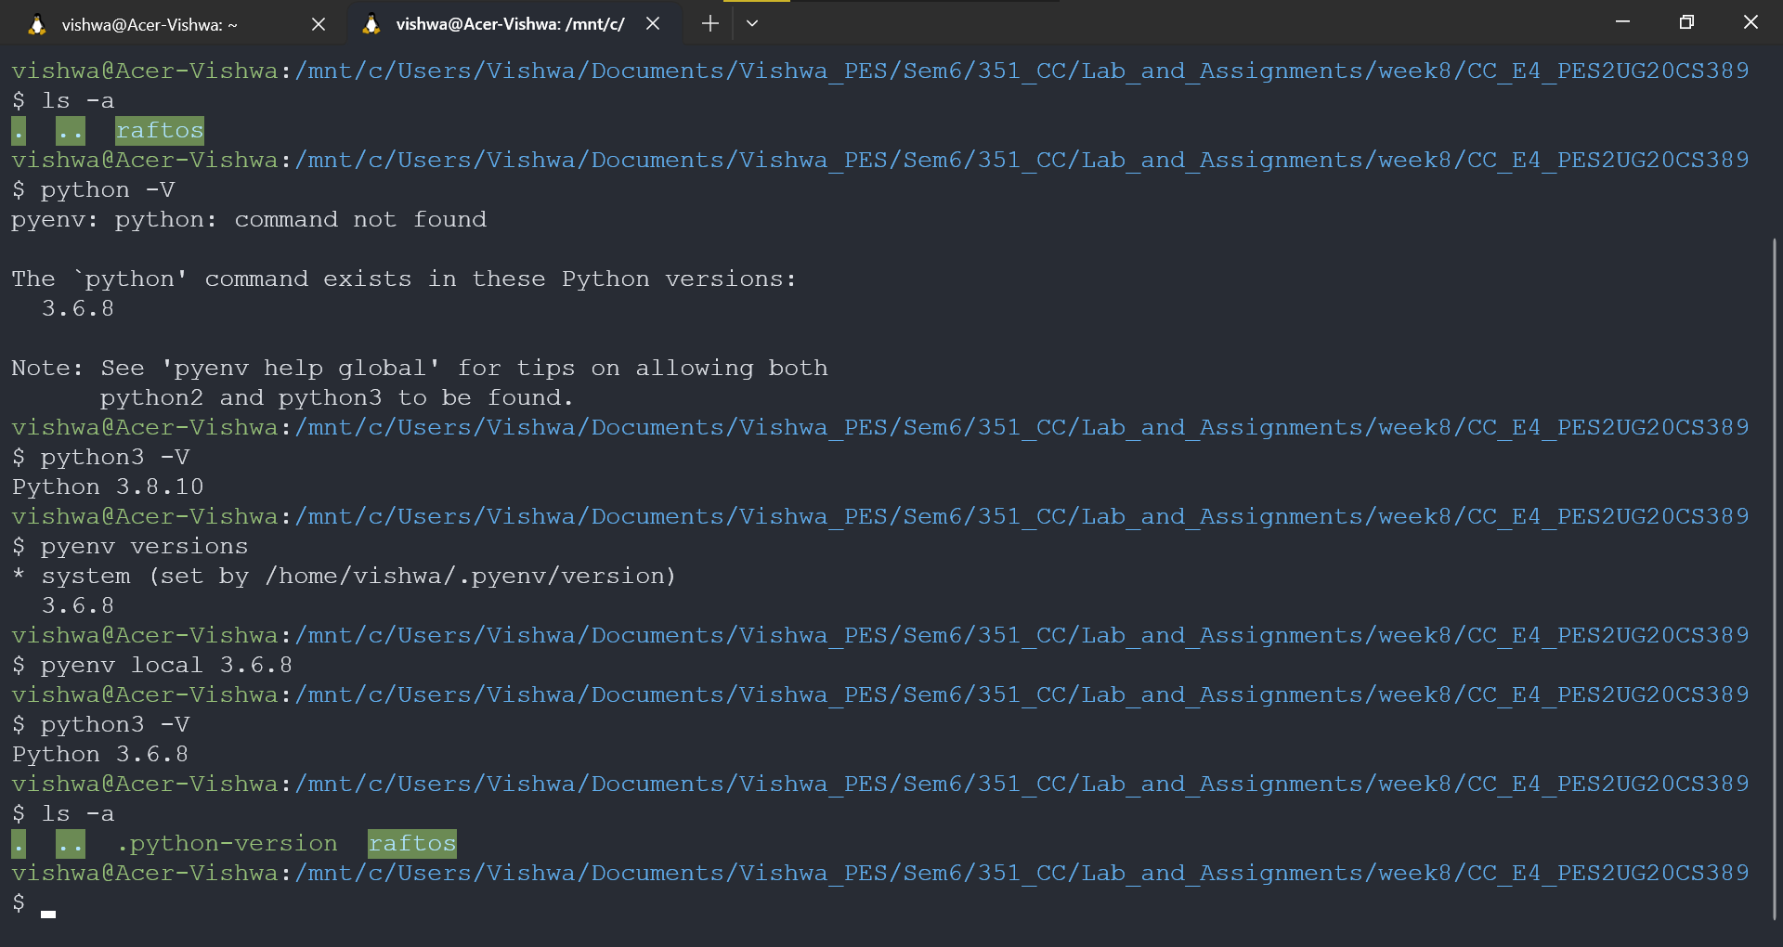

2a.

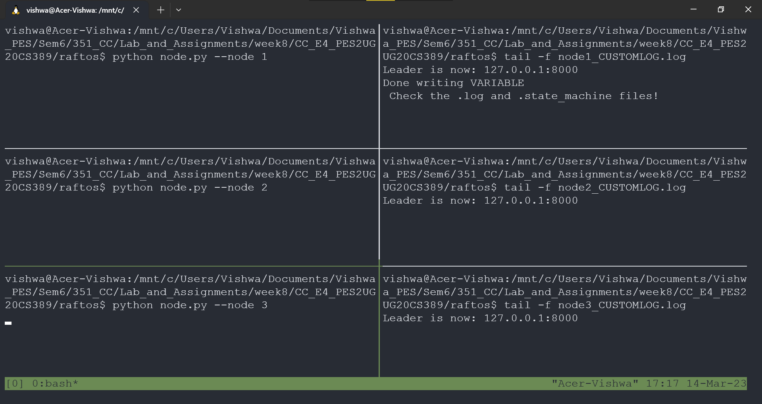

2b.

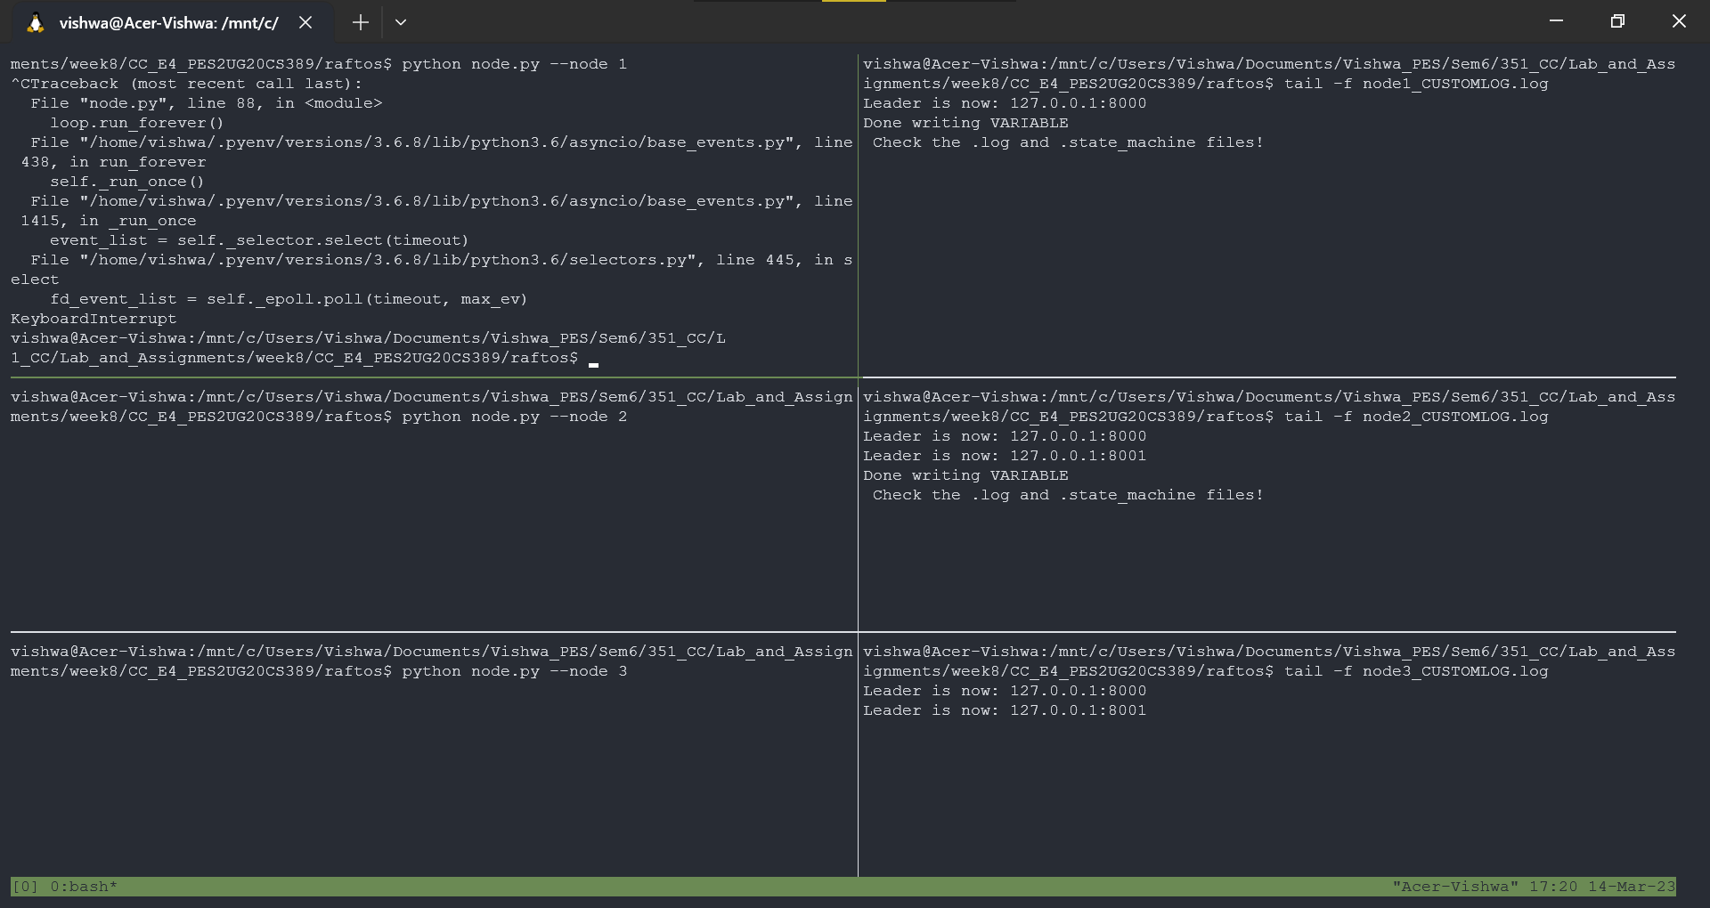

2c.

